Joseph Raetano
Class: COSC 494/557, Fall 2013.

Assignment: #3

Topic: D3.js Introduction

Date Assigned: 6:20pm, Tuesday, September 24, 2013.

Date Due: 11:59pm, Tuesday, October 8, 2013.

Ref: Code adapted from http://bl.ocks.org/mbostock

Report: Submit a report with sections that address the following questions:

1. Tell me about the scatterplot you created. How do I run it or access it? How do I use it? What features did you add? Describe some insights you found in the data set. Include screenshots as necessary.

The scatterplot was adapted from the above reference. I run the scatterplot using Dreamweaver’s split code window live function. See below:

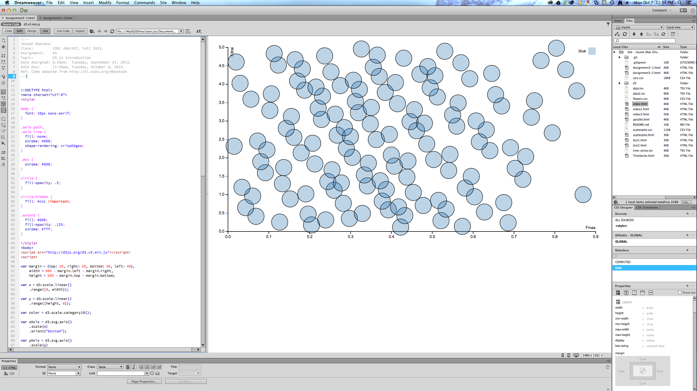

For you to access this code, unzip Raetano_assignment3.zip in a local folder, change current console directory to this folder. If you do not have Dreamweaver but have Python installed, start your Python webserver (change directory to where the index.html is) to test locally "python -m SimpleHTTPServer 8888". I increased the size of the disks and adjusted the opacity.

1. Tell me about the multi-series line plot. How do I run it or access it? How do I use it? What features did you add? Describe some insights you found in the data set. Include screenshots as necessary.

You run this code the same way as described above. I added a legend to describe the lines and color.

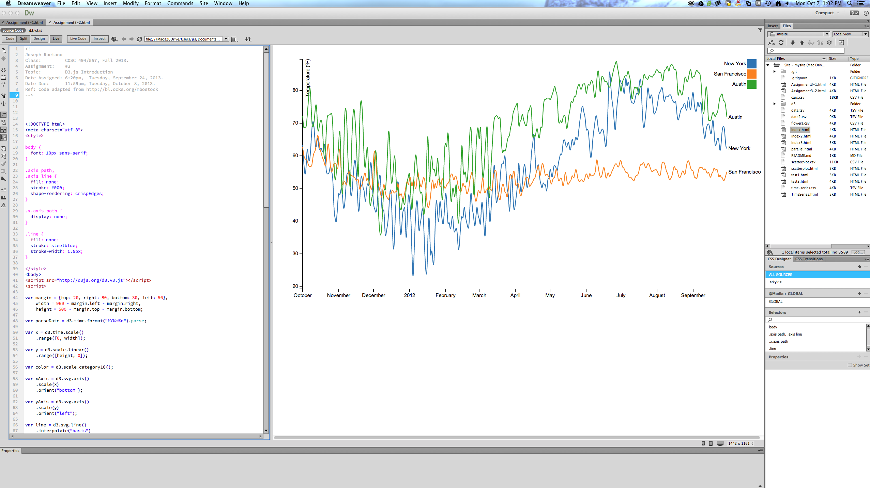

1. Do you think it is better to show the scatterplot points as semi-transparent discs or color-filled circles? Justify your answer.
2. Given your experience with the Processing assignment, how does your experience in this assignment compare? Was it easier to use d3.js? Do you think one is more advantageous than the other? What are the strengths and weaknesses of each approach?